Bangladesh Medical Association (BMA)
List of Life Member-249
15. BMA Dinajpur Branch

Sl No | Voter No | Voter Details
1 | Voter No  LM-1500001  No Image | DR. MD. BORHANUDDIN  F/Name:  M/Name:  BM & DC Reg. No:  NID:  Cell:  Address: Eid-Gah Basthi Dinajpur  Blood Group:
2 | Voter No  LM-1500002  No Image | DR. MRS. SUFIA AHMED  F/Name:  M/Name:  BM & DC Reg. No:  NID:  Cell:  Address: Golkuthe,Dinajpur.  Blood Group:
3 | Voter No  LM-1500003  No Image | DR. MD. ABU TAHER  F/Name:  M/Name:  BM & DC Reg. No:  NID:  Cell:  Address: Atomic Energy Centre Dinajpur  Blood Group:
4 | Voter No  LM-1500004  No Image | DR. MD. FAZLUR RAHMAN  F/Name:  M/Name:  BM & DC Reg. No:  NID:  Cell:  Address: Ex-Civil Surgeon Dinajpur  Blood Group:
5 | Voter No  LM-1500005  No Image | DR. ABU MOHAMMAD MOHSINUR RAHMAN  F/Name:  M/Name:  BM & DC Reg. No:  NID:  Cell:  Address: South Balu Bari Dinajpur  Blood Group:
6 | Voter No  LM-1500006  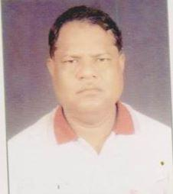 | DR. MD. ZAHURUL ISLAM  F/Name:  M/Name:  BM & DC Reg. No:  NID:  Cell:  Address: Consultant Gynae & OBS General Hospital Dinajpur  Blood Group:
7 | Voter No  LM-1500007  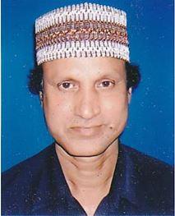 | DR. MD.ABDUL GAFUR MONDAL  F/Name: Md. Tasim Uddin Mondal  M/Name:  BM & DC Reg. No:  NID:  Cell:  Address: Associate Professor, Transfusion Medicine (Blood Tranfusion) Dinajpur Medical College, Dinajpur  Blood Group:
8 | Voter No  LM-1500008  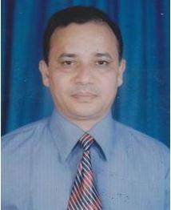 | DR. MD. HAFIZUL ISLAM  F/Name: Late Jafarulla Sarker  M/Name:  BM & DC Reg. No:  NID:  Cell:  Address: Pahar Pur Dinajpur  Blood Group:
9 | Voter No  LM-1500009  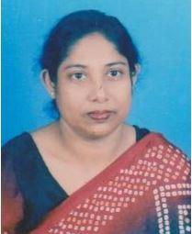 | DR. MASTURA BEGUM  F/Name: Late Muniruddin Ahmed  M/Name:  BM & DC Reg. No:  NID:  Cell:  Address: Pahar Pur Dinajpur  Blood Group:
10 | Voter No  LM-1500010  No Image | DR. SHAHIDULLAH CHOWDHURY  F/Name:  M/Name:  BM & DC Reg. No:  NID:  Cell:  Address: Baluadanga Dinajpur  Blood Group:
11 | Voter No  LM-1500011  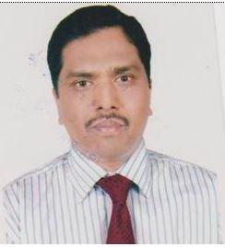 | DR. MD. ZIAUL HAQUE  F/Name: Md. Mainul Haque  M/Name:  BM & DC Reg. No:  NID:  Cell:  Address: Nimtola, Kotwali, Dinajpur.  Blood Group:
12 | Voter No  LM-1500012  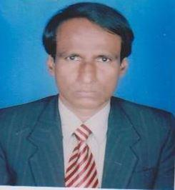 | DR. CHOWDHURY MD. MUSHFIQUR RAHMAN  F/Name:  M/Name:  BM & DC Reg. No:  NID:  Cell:  Address: Plot No, 108, Block - 7, New Town, Dinajpur  Blood Group:
13 | Voter No  LM-1500013  No Image | DR. S.M ABUL KALAM  F/Name:  M/Name:  BM & DC Reg. No:  NID:  Cell:  Address: Civil Surgeon Dinajpur  Blood Group:
14 | Voter No  LM-1500014  No Image | DR. MD. SHAH ABDUL AHAD  F/Name:  M/Name:  BM & DC Reg. No:  NID:  Cell:  Address: TH. & FPO, Sadar Dinajpur  Blood Group:
15 | Voter No  LM-1500015  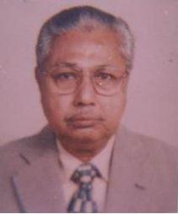 | DR. ASIMUDDIN AHMED  F/Name:  M/Name:  BM & DC Reg. No:  NID:  Cell:  Address: Mission Road Dinajpur  Blood Group:
16 | Voter No  LM-1500016  No Image | DR. RUBINA TABASSUM  F/Name:  M/Name:  BM & DC Reg. No:  NID:  Cell:  Address: Kalitola Dinajpur  Blood Group:
17 | Voter No  LM-1500017  No Image | DR. LAILA PARVEEN BANU  F/Name:  M/Name:  BM & DC Reg. No:  NID:  Cell:  Address: Consultant Gynae., Mission Road Dinajpur  Blood Group:
18 | Voter No  LM-1500018  No Image | DR. MD. SHAHAJAHAN NEWAZ  F/Name:  M/Name:  BM & DC Reg. No:  NID:  Cell:  Address:  Blood Group:  TRANSFERED to BMA Dhaka City  LM-1405543
19 | Voter No  LM-1500019  No Image | DR. MD. ABU ZAFOR  F/Name:  M/Name:  BM & DC Reg. No:  NID:  Cell:  Address:  Blood Group:
20 | Voter No  LM-1500020  No Image | DR. G.M. MIZANUR RAHMAN  F/Name:  M/Name:  BM & DC Reg. No:  NID:  Cell:  Address: Dinajpur  Blood Group:  E X P I R E D
21 | Voter No  LM-1500021  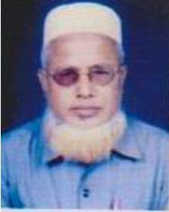 | DR. MD. LOKMAN ALI  F/Name:  M/Name:  BM & DC Reg. No:  NID:  Cell:  Address: North Sujapur, Hospital Road, Phulbari Dinajpur  Blood Group:
22 | Voter No  LM-1500022  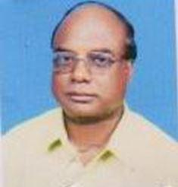 | DR. MD. IMAR UDDIN  F/Name:  M/Name:  BM & DC Reg. No:  NID:  Cell:  Address: Th. & FPO, Birampur Dinajpur  Blood Group:
23 | Voter No  LM-1500023  No Image | DR. A.T.M. FARIDUDDIN  F/Name:  M/Name:  BM & DC Reg. No:  NID:  Cell:  Address:  Blood Group:
24 | Voter No  LM-1500024  No Image | DR. JAHANGIR ALAM  F/Name:  M/Name:  BM & DC Reg. No:  NID:  Cell:  Address: House J-3/4, Block- 2, New Town Dinajpur  Blood Group:
25 | Voter No  LM-1500025  No Image | DR. A. H. M SHAFIQUR RAHMAN  F/Name: Mr. Taher Uddin Ahmed  M/Name:  BM & DC Reg. No:  NID:  Cell:  Address: Assoc. Prof., Community Medicine, Dinajpur Medical College Hosptial, Dinajpur  Blood Group:
26 | Voter No  LM-1500026  No Image | DR. MD. ABDUL BASED  F/Name:  M/Name:  BM & DC Reg. No:  NID:  Cell:  Address:  Blood Group:  TRANSFERED to BMA Dhaka City  LM-1405543
27 | Voter No  LM-1500027  No Image | DR. MD. RUHUL AMIN  F/Name: Md. Atahar Hossain  M/Name:  BM & DC Reg. No:  NID:  Cell:  Address: Emargency Medical Officer General Hospital Dinajpur  Blood Group:
28 | Voter No  LM-1500028  No Image | DR. MD. ABUL KALAM AZAD  F/Name:  M/Name:  BM & DC Reg. No:  NID:  Cell:  Address: Emargency Medical Officer, General Hospital, Dinajpur.  Blood Group:  TRANSFERED to BMA Dhaka City  LM-1405543
29 | Voter No  LM-1500029  No Image | DR. MD. RIZAUL HOQUE CHOWDHURY  F/Name: Md. Emdad Ali Chodhury  M/Name:  BM & DC Reg. No:  NID:  Cell:  Address: Medical Officer Urban Dispensary Dinajpur  Blood Group:
30 | Voter No  LM-1500030  No Image | DR. MD. ANWARUL HUQ  F/Name: Late Sk. Md. Golam Rabbani  M/Name:  BM & DC Reg. No:  NID:  Cell:  Address: Senior Consultant Surgery General Hospital Dinajpur  Blood Group:
31 | Voter No  LM-1500031  No Image | DR. NAZIM UDDIN AHMED  F/Name: Mvi. Zafir Uddin Ahmed  M/Name:  BM & DC Reg. No:  NID:  Cell:  Address: Khetri Para Dinajpur  Blood Group:
32 | Voter No  LM-1500032  No Image | DR. S. KHALILULLAH  F/Name: Late Syed Amirullah  M/Name:  BM & DC Reg. No:  NID:  Cell:  Address:  Blood Group:  E X P I R E D
33 | Voter No  LM-1500033  No Image | DR. MOHAMMAD MOHSIN  F/Name:  M/Name:  BM & DC Reg. No:  NID:  Cell:  Address:  Blood Group:  TRANSFERED to BMA Dhaka City  LM-1405543
34 | Voter No  LM-1500034  No Image | DR. MOSAMMAT SHAHINA AKHTER BEGUM  F/Name: Late Md. Mostafizur Rahman  M/Name:  BM & DC Reg. No:  NID:  Cell:  Address: South Balu Bari Dinajpur  Blood Group:
35 | Voter No  LM-1500035  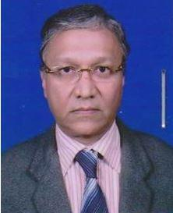 | DR. CHOWDHURY MOSADDEQUL ISDANI  F/Name: Mr. Mainuddin Ahmed Chy  M/Name:  BM & DC Reg. No:  NID:  Cell:  Address: Idgahbasti Dinajpur  Blood Group:
36 | Voter No  LM-1500036  No Image | DR. KAILASH CHANDRA ROY  F/Name: Late Ram Babu Roy  M/Name:  BM & DC Reg. No:  NID:  Cell:  Address: Barabandar, Kotwali Dinajpur  Blood Group:
37 | Voter No  LM-1500037  No Image | DR. AMATUN NOOR  F/Name: Mehrab Ali  M/Name:  BM & DC Reg. No:  NID:  Cell:  Address: Sr. Medical Officer, Khetri Para Dinajpur  Blood Group:
38 | Voter No  LM-1500038  No Image | DR. AZIZUDDIN AHMED  F/Name: Al Haj Rahimuddin Ahmed  M/Name:  BM & DC Reg. No:  NID:  Cell:  Address: Dinajpur  Blood Group:  E X P I R E D
39 | Voter No  LM-1500039  No Image | DR. GOUTAM KUMAR ROY  F/Name:  M/Name:  BM & DC Reg. No:  NID:  Cell:  Address:  Blood Group:  TRANSFERED to BMA Dhaka City  LM-1405543
40 | Voter No  LM-1500040  No Image | DR. MD. ABDUL WAHED  F/Name: Abbas Ali Sarkar  M/Name:  BM & DC Reg. No:  NID:  Cell:  Address:  Blood Group:
41 | Voter No  LM-1500041  No Image | DR. MD. MASIR UDDIN  F/Name: Late Nazir Uddin Ahmed  M/Name:  BM & DC Reg. No:  NID:  Cell:  Address: Idgah Abasik Alaka, Dinajpur  Blood Group:
42 | Voter No  LM-1500042  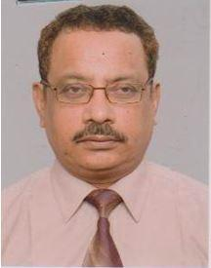 | DR. MD. GOLAM MUSTAFA  F/Name: Late Md. Hafizuddin  M/Name:  BM & DC Reg. No:  NID:  Cell:  Address: Munshi Para Road Dinajpur  Blood Group:
43 | Voter No  LM-1500043  No Image | DR. MD. RAJEB - E- RAHMAN  F/Name: Late Md. Fataur Rahman  M/Name:  BM & DC Reg. No:  NID:  Cell:  Address: Medical Officer Cheradangi Sub Centre Sadar, Dinajpur.  Blood Group:
44 | Voter No  LM-1500044  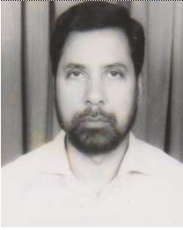 | DR. MD. MUZAFFAR RAHMAN  F/Name:  M/Name:  BM & DC Reg. No:  NID:  Cell:  Address: Mina Villa, Sastitola Station Road Dinajpur  Blood Group:
45 | Voter No  LM-1500045  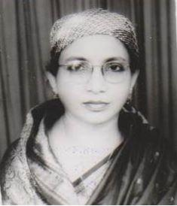 | DR. QUAMRUN NESA  F/Name:  M/Name:  BM & DC Reg. No:  NID:  Cell:  Address: Mina Villa, Sastitola Station Road Dinajpur  Blood Group:
46 | Voter No  LM-1500046  No Image | DR. FARZANA HAQUE  F/Name:  M/Name:  BM & DC Reg. No:  NID:  Cell:  Address:  Blood Group:  TRANSFERED to BMA Dhaka City  LM-1405543
47 | Voter No  LM-1500047  No Image | DR. MD. AZIZUR RAHMAN  F/Name:  M/Name:  BM & DC Reg. No:  NID:  Cell:  Address: Thana Health Compplex B.I.R.O.L, Dinajpur  Blood Group:  TRANSFERED to BMA Dhaka City  LM-1405543
48 | Voter No  LM-1500048  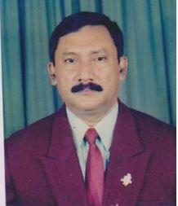 | DR. I.F.M. SHAHIDUL ISLAM KHAN  F/Name:  M/Name:  BM & DC Reg. No:  NID:  Cell:  Address: B.N.S.B. Eye Hospital, New Town Dinajpur  Blood Group:
49 | Voter No  LM-1500049  No Image | DR. MD. ANSAR ALI  F/Name:  M/Name:  BM & DC Reg. No:  NID:  Cell:  Address: Block- K-1, New Town Dinajpur  Blood Group:
50 | Voter No  LM-1500050  No Image | DR. K.A. MD. BADRUD-DOHA  F/Name: Mr. Rafique Uddin Ahmed  M/Name:  BM & DC Reg. No:  NID:  Cell:  Address: General Hospital Dinajpur  Blood Group:
51 | Voter No  LM-1500051  No Image | DR. MEHERUN NAHAR  F/Name: Late Nizamuddin Ahmed  M/Name:  BM & DC Reg. No:  NID:  Cell:  Address: General Hospital Dinajpur  Blood Group:
52 | Voter No  LM-1500052  No Image | DR. MD. ILEAS ALI KHAN  F/Name: Late Md. Ishaque Ali Khan  M/Name:  BM & DC Reg. No:  NID:  Cell:  Address: Labani, North Balubari Dinajpur  Blood Group:
53 | Voter No  LM-1500053  No Image | DR. MD. MOKSED ALI  F/Name: Late Jahiruddin Bepari  M/Name:  BM & DC Reg. No:  NID:  Cell:  Address: Thana Health Compplex Birganj Dinajpur  Blood Group:
54 | Voter No  LM-1500054  No Image | DR. MD. ASGAR ALI  F/Name: Jaheruddin Ahmed  M/Name:  BM & DC Reg. No:  NID:  Cell:  Address: Thana Health Compplex Khansama Birol Dinajpur  Blood Group:
55 | Voter No  LM-1500055  No Image | DR. MUHAMMAD KHURSHIDUL ISLAM  F/Name: Late Umeruddin Chowdhury  M/Name:  BM & DC Reg. No:  NID:  Cell:  Address: Ex-Assoc. Prof. ICD&H, Mohakhali Dhaka  Blood Group:
56 | Voter No  LM-1500056  No Image | DR. MD. HAZRAT ALI  F/Name: Late Md. Karimuddin Sarker  M/Name:  BM & DC Reg. No:  NID:  Cell:  Address: Mushida Hat, Bochaganj Dinajpur  Blood Group:
57 | Voter No  LM-1500057  No Image | DR. A.S.M. JAHIDUL ISLAM  F/Name: Md. Azharul Islam  M/Name:  BM & DC Reg. No:  NID:  Cell:  Address: Medical Officer Civil Surgeon Office Dinajpur  Blood Group:
58 | Voter No  LM-1500058  No Image | DR. KHADIZA NAHID EVA  F/Name: Md. Nazrul Islam Chowdhury  M/Name:  BM & DC Reg. No:  NID:  Cell:  Address: Meternity Child Welfare Centre Balu Bari Dinajpur  Blood Group:
59 | Voter No  LM-1500059  No Image | DR. MD. AHAD ALI  F/Name: Mr. Md. Zahir Uddin  M/Name:  BM & DC Reg. No:  NID:  Cell:  Address: Doctor’s Hospital Balubari, Dinajpur  Blood Group:
60 | Voter No  LM-1500060  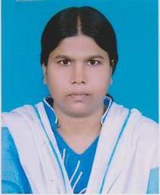 | DR. AFROZA YASMIN  F/Name: Mr. Md. Azharul Islam  M/Name:  BM & DC Reg. No:  NID:  Cell:  Address: Doctor’s Hospital Balubari, Dinajpur  Blood Group:
61 | Voter No  LM-1500061  No Image | DR. MD. ZAINUL ABEDIN  F/Name: Md. Siddique Hossain  M/Name:  BM & DC Reg. No:  NID:  Cell:  Address: South Chawliapatty Dinajpur  Blood Group:
62 | Voter No  LM-1500062  No Image | DR. MOMTAZ BEGUM POLLY  F/Name: Late Ayenul Haque  M/Name:  BM & DC Reg. No:  NID:  Cell:  Address: South Chawliapatty Dinajpur  Blood Group:
63 | Voter No  LM-1500063  No Image | DR. A.G.M GOLZAR RAHMAN  F/Name: Late Al Haj Asan Ullah Mondal  M/Name:  BM & DC Reg. No:  NID:  Cell:  Address: Assistant Prof. Ophthalmology Dinajpur Medical College Dinajpur  Blood Group:
64 | Voter No  LM-1500064  No Image | DR. MUSADDIQ HUSSAIN  F/Name: Mafizul Haque  M/Name:  BM & DC Reg. No:  NID:  Cell:  Address: Assoc. Prof. Medicine Dinajpur Medical College Dinajpur  Blood Group:
65 | Voter No  LM-1500065  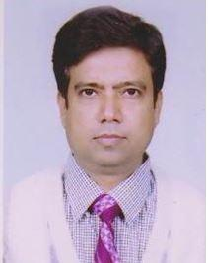 | DR. AFSAR AL MAHMUD  F/Name: Late Kalimuddin Ahmed  M/Name:  BM & DC Reg. No:  NID:  Cell:  Address: Diabetic Hospital Dinajpur  Blood Group:
66 | Voter No  LM-1500066  No Image | DR. MD. AZIZUL ISLAM  F/Name: Late Jasimuddin Ahmed  M/Name:  BM & DC Reg. No:  NID:  Cell:  Address: Station Road, Dinajpur  Blood Group:
67 | Voter No  LM-1500067  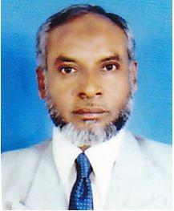 | DR. MIR JALALUDDIN AHMED  F/Name: Late Mir Akbar Ali  M/Name:  BM & DC Reg. No:  NID:  Cell:  Address: Ex-Civil Surgeon Dinajpur  Blood Group:
68 | Voter No  LM-1500068  No Image | DR. ALHAJ SAMIRUDDIN AHMED  F/Name:  M/Name:  BM & DC Reg. No:  NID:  Cell:  Address: Bashuniapatty Dinajpur  Blood Group:
69 | Voter No  LM-1500069  No Image | DR. A.B.M AMINUR RAHMAN  F/Name:  M/Name:  BM & DC Reg. No:  NID:  Cell:  Address: Dinajpur  Blood Group:  E X P I R E D
70 | Voter No  LM-1500070  No Image | DR. MD. ABDUL QUADER  F/Name:  M/Name:  BM & DC Reg. No:  NID:  Cell:  Address: Eidgahbasti Dinajpur  Blood Group:
71 | Voter No  LM-1500071  No Image | DR. ALHAJ SK. LUTFUR RAHMAN  F/Name:  M/Name:  BM & DC Reg. No:  NID:  Cell:  Address:  Blood Group:
72 | Voter No  LM-1500072  No Image | DR. SULTANA ROKEYA  F/Name:  M/Name:  BM & DC Reg. No:  NID:  Cell:  Address: Vill.- Balubari, Tha- Kotowali Dinajpur  Blood Group:
73 | Voter No  LM-1500073  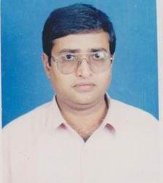 | DR. IRESH CHANDRA BHOTTACHARYA  F/Name: Late Gopal Chandra Bhattacharyya  M/Name:  BM & DC Reg. No:  NID:  Cell:  Address: Nimtola, Dinajpur  Blood Group:
74 | Voter No  LM-1500074  No Image | DR. AHMED KHAIRUL ALAM  F/Name:  M/Name:  BM & DC Reg. No:  NID:  Cell:  Address: RMO, Dinajpur Medical College Hosptial, Dinajpur  Blood Group:
75 | Voter No  LM-1500075  No Image | DR. MD . WALIUL ISLAM  F/Name:  M/Name:  BM & DC Reg. No:  NID:  Cell:  Address:  Blood Group:
76 | Voter No  LM-1500076  No Image | DR. SR. DEBNATH  F/Name:  M/Name:  BM & DC Reg. No:  NID:  Cell:  Address: Lamb Hospital, Parbatipur Dinajpur  Blood Group:
77 | Voter No  LM-1500077  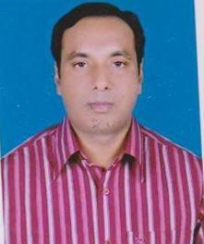 | DR. HARIPADA SARKAR  F/Name:  M/Name:  BM & DC Reg. No:  NID:  Cell:  Address:  Blood Group:
78 | Voter No  LM-1500078  No Image | DR. MD. MONZUR RAHMAN  F/Name:  M/Name:  BM & DC Reg. No:  NID:  Cell:  Address: Lamb Hospital, Parbatipur Dinajpur  Blood Group:
79 | Voter No  LM-1500079  No Image | DR. ROWSHAN ARA  F/Name:  M/Name:  BM & DC Reg. No:  NID:  Cell:  Address:  Blood Group:
80 | Voter No  LM-1500080  No Image | DR. MD. NASIM HOSSAIN  F/Name:  M/Name:  BM & DC Reg. No:  NID:  Cell:  Address: Lecturer, Pharmacology Dept., Dinajpur Medical College Hosptial, Dinajpur  Blood Group:  TRANSFERED to BMA Dhaka City  LM-1405543
81 | Voter No  LM-1500081  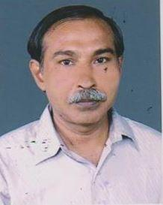 | DR. SUDHANGSHU SHEKHAR BHATTACHARYYA  F/Name:  M/Name:  BM & DC Reg. No:  NID:  Cell:  Address: Nimtola Dinajpur Medical College Hosptial Dinajpur  Blood Group:
82 | Voter No  LM-1500082 | DR. MD. TAZAKKHARUZZAMAN  F/Name:  M/Name:  BM & DC Reg. No:  NID:  Cell:  Address: Associate Surgeon BNSB Eye Hospital Dinajpur  Blood Group:
83 | Voter No  LM-1500083  No Image | DR. MD. HAIDER ALI  F/Name:  M/Name:  BM & DC Reg. No:  NID:  Cell:  Address:  Blood Group:  TRANSFERED to BMA Dhaka City  LM-1405543
84 | Voter No  LM-1500084  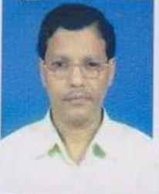 | DR. SHYAMAL KRISHNA MANDOL  F/Name:  M/Name:  BM & DC Reg. No:  NID:  Cell:  Address: Doctor Para, Badargonj, Dinajpur.  Blood Group:
85 | Voter No  LM-1500085  No Image | DR. MD. ABDUL HAQUE KHAN  F/Name:  M/Name:  BM & DC Reg. No:  NID:  Cell:  Address: Medicla Officer Thana Health Complex Parbatipur Dinajpur  Blood Group:
86 | Voter No  LM-1500086  No Image | DR. MD. A.N. NURUL ISLAM CHOWDHURY  F/Name:  M/Name:  BM & DC Reg. No:  NID:  Cell:  Address: Munshi Para, Dinajpur  Blood Group:
87 | Voter No  LM-1500087  No Image | DR. MAHBUBA BEGUM  F/Name:  M/Name:  BM & DC Reg. No:  NID:  Cell:  Address: Munshi Para, Dinajpur  Blood Group:
88 | Voter No  LM-1500088  No Image | DR. MD. NAZRUL ISLAM  F/Name:  M/Name:  BM & DC Reg. No:  NID:  Cell:  Address: Medical Officer, Hajee Mohammad Danesh Agriculture College Dinajpur  Blood Group:
89 | Voter No  LM-1500089  No Image | DR. WAHIDA BEGUM  F/Name:  M/Name:  BM & DC Reg. No:  NID:  Cell:  Address: Associate Surgeon BNSB Eye Hospital Dinajpu  Blood Group:
90 | Voter No  LM-1500090  No Image | DR. MOHAMMED MAHTAB UDDIN HASAN  F/Name:  M/Name:  BM & DC Reg. No:  NID:  Cell:  Address: Asst. Prof. Medicine Dinajpur Medical College Hosptial Dinajpur  Blood Group:
91 | Voter No  LM-1500091  No Image | DR. SANTANU BASU  F/Name:  M/Name:  BM & DC Reg. No:  NID:  Cell:  Address: Bashuniapatty Dinajpur  Blood Group:
92 | Voter No  LM-1500092  No Image | DR. SUBIR KUMAR SARKAR  F/Name:  M/Name:  BM & DC Reg. No:  NID:  Cell:  Address: Asstt. Prof. Anatomy Dinajpur Medical College Hosptial Dinajpur  Blood Group:
93 | Voter No  LM-1500093  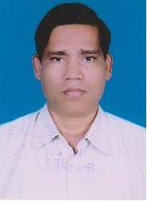 | DR. SUBIR KUMAR SARKER  F/Name:  M/Name:  BM & DC Reg. No:  NID:  Cell:  Address: Vill.- Khalpara Dinajpur  Blood Group:
94 | Voter No  LM-1500094  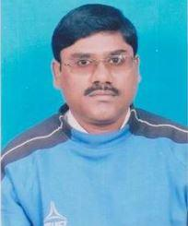 | DR. GOPI NATH BASAK  F/Name:  M/Name:  BM & DC Reg. No:  NID:  Cell:  Address: Kalitola, Dinajpur  Blood Group:
95 | Voter No  LM-1500095  No Image | DR. MD. RAFIQUL ISLAM  F/Name:  M/Name:  BM & DC Reg. No:  NID:  Cell:  Address:  Blood Group:  TRANSFERED to BMA Dhaka City  LM-1405543
96 | Voter No  LM-1500096  No Image | DR. MD. SHAH ALAM  F/Name:  M/Name:  BM & DC Reg. No:  NID:  Cell:  Address: Medical Officer(MCH-FP) Birganj Dinajpur  Blood Group:
97 | Voter No  LM-1500097  No Image | DR. MD. MOFAKKARUL ISLAM  F/Name:  M/Name:  BM & DC Reg. No:  NID:  Cell:  Address: Islam Clinic Natun Bazar, Parbatipur Dinajpur  Blood Group:
98 | Voter No  LM-1500098  No Image | DR. MD. ABDUL HAMID  F/Name:  M/Name:  BM & DC Reg. No:  NID:  Cell:  Address:  Blood Group:  TRANSFERED to BMA Dhaka City  LM-1405543
99 | Voter No  LM-1500099  No Image | DR. MD. ABDUR RAZZAQUE  F/Name:  M/Name:  BM & DC Reg. No:  NID:  Cell:  Address:  Blood Group:  TRANSFERED to BMA Dhaka City  LM-1405543
100 | Voter No  LM-1500100  No Image | DR. A.M. SELIM REZA  F/Name:  M/Name:  BM & DC Reg. No:  NID:  Cell:  Address: RMO. THC. Nowabagonj Dinajpur  Blood Group:  TRANSFERED to BMA Dhaka City  LM-1405543
101 | Voter No  LM-1500101  No Image | DR. MD. SAIDUL HAQUE  F/Name:  M/Name:  BM & DC Reg. No:  NID:  Cell:  Address: RMO, Thana Health Complex Chirirbandar Dinajpur  Blood Group:
102 | Voter No  LM-1500102  No Image | DR. MD. LUTFULLAH  F/Name:  M/Name:  BM & DC Reg. No:  NID:  Cell:  Address: TH-FPO, Thana Health Complex Birganj Dinajpur  Blood Group:
103 | Voter No  LM-1500103  No Image | DR. MD. DABIR UDDIN SARDAR  F/Name:  M/Name:  BM & DC Reg. No:  NID:  Cell:  Address:  Blood Group:  TRANSFERED to BMA Dhaka City  LM-1405543
104 | Voter No  LM-1500104  No Image | DR. KAMRUN NAHAR  F/Name:  M/Name:  BM & DC Reg. No:  NID:  Cell:  Address:  Blood Group:  TRANSFERED to BMA Dhaka City  LM-1405543
105 | Voter No  LM-1500105  No Image | DR. MAHMUD HASAN  F/Name:  M/Name:  BM & DC Reg. No:  NID:  Cell:  Address:  Blood Group:  TRANSFERED to BMA Dhaka City  LM-1405543
106 | Voter No  LM-1500106  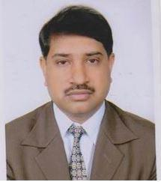 | DR. BOACHU KUMAR BOSE  F/Name:  M/Name:  BM & DC Reg. No:  NID:  Cell:  Address: Barabandar, Dinajpur  Blood Group:
107 | Voter No  LM-1500107  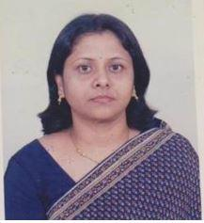 | DR. KANTA ROY RIMI  F/Name:  M/Name:  BM & DC Reg. No:  NID:  Cell:  Address: Barabandar, Dinajpur  Blood Group:
108 | Voter No  LM-1500108  No Image | DR. RAMA NANDA BASAK  F/Name:  M/Name:  BM & DC Reg. No:  NID:  Cell:  Address: Baragurgola, Dinajpur  Blood Group:
109 | Voter No  LM-1500109  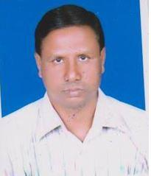 | DR. LIAKAT ALI  F/Name:  M/Name:  BM & DC Reg. No:  NID:  Cell:  Address: Vill. Kashimde Kotwali Dinajpur  Blood Group:
110 | Voter No  LM-1500110  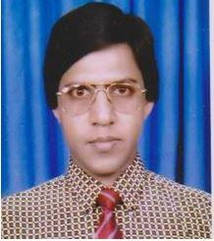 | DR. MD. SAIDUR RAHMAN CHOWDHURY  F/Name:  M/Name:  BM & DC Reg. No:  NID:  Cell:  Address: Baitulamin, Mohazonpara Dinajpur  Blood Group:
111 | Voter No  LM-1500111  No Image | DR. MRS. RABEKA KHATUN  F/Name: Late Md. Aziz Uddin Mondal  M/Name:  BM & DC Reg. No:  NID:  Cell:  Address: Assoc. Prof., Gynae Dept. Dinajpur Medical College, Dinajpur.  Blood Group: O+
112 | Voter No  LM-1500112  No Image | DR. MD. AZIZAR RHAMAN  F/Name: Late Khazia Paramanik  M/Name:  BM & DC Reg. No:  NID:  Cell:  Address: Asstt. Prof., Pathology Dept. Dinajpur Medical College, Dinajpur.  Blood Group:
113 | Voter No  LM-1500113  No Image | DR. MD. KHALID HASAN  F/Name:  M/Name:  BM & DC Reg. No:  NID:  Cell:  Address: N/A  Blood Group:
114 | Voter No  LM-1500114  No Image | DR. MD. TAIBUR RAHMAN  F/Name:  M/Name:  BM & DC Reg. No:  NID:  Cell:  Address: Asstt. Prof., Surgery Dinajpur Medical College Dinajpur  Blood Group:
115 | Voter No  LM-1500115  No Image | DR. UTTOM KUMAR BOSAK  F/Name:  M/Name:  BM & DC Reg. No:  NID:  Cell:  Address:  Blood Group:  TRANSFERED to BMA Dhaka City  LM-1405543
116 | Voter No  LM-1500116  No Image | DR. MD. YUSUF ALI  F/Name:  M/Name:  BM & DC Reg. No:  NID:  Cell:  Address: Asstt. Prof., Surgery Dinajpur Medical College, Dinajpur.  Blood Group:
117 | Voter No  LM-1500117  No Image | DR. MD. MOMINUL HAQUE  F/Name:  M/Name:  BM & DC Reg. No:  NID:  Cell:  Address: Dinajpur  Blood Group:
118 | Voter No  LM-1500118  No Image | DR. MD. AZIZUL KAHHAR  F/Name: Late Momtaz Ali  M/Name:  BM & DC Reg. No:  NID:  Cell:  Address: Associate Professor, Medicine Dinajpur Medical College Hosptial Dinajpur  Blood Group:
119 | Voter No  LM-1500119  No Image | DR. MD. AMIR ALI  F/Name: Late Abdur Rahman  M/Name:  BM & DC Reg. No:  NID:  Cell:  Address: 4-D, 5/6, New Town Dinajpur  Blood Group:
120 | Voter No  LM-1500120  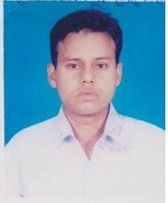 | DR. MOHAMMAD MONJUR MORSHED HOSS.  F/Name: Mohammad Hossain  M/Name:  BM & DC Reg. No:  NID:  Cell:  Address: Munshipara, Dinajpur  Blood Group:
121 | Voter No  LM-1500121  No Image | DR. ABUL FAJAL MD. MOSTOFA SARKER  F/Name: Late Yusuf Ali Miah  M/Name:  BM & DC Reg. No:  NID:  Cell:  Address: Eidgah Residential Area Dinajpur  Blood Group:
122 | Voter No  LM-1500122  No Image | DR. MD. RAFIQUL ISLAM  F/Name: Md. Rahamat Ali  M/Name:  BM & DC Reg. No:  NID:  Cell:  Address: Assoc. Prof. Forensic Medicine Dinajpur Medical College Hosptial Dinajpur  Blood Group:
123 | Voter No  LM-1500123  No Image | DR. RAISUDDIN AHMED  F/Name: Late Abdus Satter  M/Name:  BM & DC Reg. No:  NID:  Cell:  Address: Medical Officer, Chest Disease Clinic Dinajpur  Blood Group:
124 | Voter No  LM-1500124  No Image | DR. MD. AFTAB HOSSAIN  F/Name: Late Ahsan Uddin  M/Name:  BM & DC Reg. No:  NID:  Cell:  Address: Asst. Prof. Anaesthesiology Dinajpur Medical College Hosptial Dinajpur  Blood Group:
125 | Voter No  LM-1500125  No Image | DR. JAHANARA BEGUM  F/Name: Late Jalilur Rahman  M/Name:  BM & DC Reg. No:  NID:  Cell:  Address: Consultant, Gynae Dinajpur Medical College Hosptial Dinajpur  Blood Group:
126 | Voter No  LM-1500126  No Image | DR. MD. NAZMUL ISLAM  F/Name: Md. Nazrul Islam  M/Name:  BM & DC Reg. No:  NID:  Cell:  Address: Shuvo Pharmacy Birganj, Dinajpur  Blood Group:
127 | Voter No  LM-1500127 | DR. MD. SHAMSUL ALAM CHOWDHURY  F/Name: Late Nasir Uddin Chowdhury  M/Name:  BM & DC Reg. No:  NID:  Cell:  Address: Senior Consultant Surgery Dinajpur Medical College Hospital Dinajpur  Blood Group:
128 | Voter No  LM-1500128  No Image | DR. SHIBESH SARKER  F/Name: Late Sita Nath Sarker  M/Name:  BM & DC Reg. No:  NID:  Cell:  Address: Asst Prof Dinajpur Medical College, Dinajpur  Blood Group:
129 | Voter No  LM-1500129  No Image | DR. MD.WAHEDUL HAQUE  F/Name: Md.Amsher Ali  M/Name:  BM & DC Reg. No:  NID:  Cell:  Address: Medical Officer Civil Surgeon Office, Dinajpur  Blood Group:
130 | Voter No  LM-1500130  No Image | DR. TARUN KUMAR ROY  F/Name: Late Madhu Sudan Roy  M/Name:  BM & DC Reg. No:  NID:  Cell:  Address: Mohalla:Khetripara, Ps: Katawali, Dist: Dinajpur  Blood Group:
131 | Voter No  LM-1500131  No Image | DR. MD. MASHIUR RAHMAN  F/Name: Dr. Shahir Uddin Ahmed  M/Name:  BM & DC Reg. No:  NID:  Cell:  Address: Block-7, Plot17, Newtown, Dinajpur.  Blood Group:
132 | Voter No  LM-1500132  No Image | DR. FARIDA YESMIN  F/Name: Prof Ruhul Amin  M/Name:  BM & DC Reg. No:  NID:  Cell:  Address: Block-7, Plot 17, Newtown, Dinajpur  Blood Group:
133 | Voter No  LM-1500133  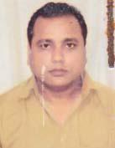 | DR. MD. MINHAZUL ISLAM  F/Name: Md. Momtaz Uddin  M/Name: Most. Mohfuz Begum  BM & DC Reg. No: 28383  NID: 2726409179250  Cell: 01715672081  Address: New town Block-5, house13, Dinajpur  Blood Group: O+
134 | Voter No  LM-1500134  No Image | DR. MD. IMRAN  F/Name:  M/Name:  BM & DC Reg. No:  NID:  Cell:  Address: Vill+Po: Rampal, P.S:Rampal, Dist: Bagerhat.  Blood Group:  TRANSFERED to BMA Dhaka City  LM-1405543
135 | Voter No  LM-1500135  No Image | DR. MD. ABDUL MANNAN CHOWDHURY  F/Name: Late Abdul Khalil Chowdhury  M/Name:  BM & DC Reg. No:  NID:  Cell:  Address: Associate Prof. Of Orthopadic Surgery Dinajpur Medical College Hospital, Dinajpur.  Blood Group:
136 | Voter No  LM-1500136 | DR. MOHAMMAD SHAHIDULLAH  F/Name:  M/Name:  BM & DC Reg. No:  NID:  Cell: 01191239252  Address: Sadar Hospital Road. Munshipara, Dinajpur.  Blood Group:
137 | Voter No  LM-1500137  No Image | DR. MD. SHAFIUL ISLAM  F/Name: Late Golzer Rahman  M/Name:  BM & DC Reg. No:  NID:  Cell:  Address: Plot # 48, Block # O2, New Town, Dinajpur.  Blood Group:
138 | Voter No  LM-1500138  No Image | DR. MD. ALTAF HOSSAIN  F/Name: Tamijuddin  M/Name:  BM & DC Reg. No:  NID:  Cell:  Address: Dibetic Hospital, Dinajpur.  Blood Group:
139 | Voter No  LM-1500139  No Image | DR. MAHJABIN ISDANI  F/Name: Chowdhury Mosaddequl Islam  M/Name:  BM & DC Reg. No:  NID:  Cell:  Address: Edgah Bosti, Dinajpur.  Blood Group:
140 | Voter No  LM-1500140  No Image | DR. DULAL CHANDRA ROY  F/Name: Dinesh Chandra Roy  M/Name:  BM & DC Reg. No:  NID:  Cell:  Address: Natunpara, Barabandra Kotawali, Dinajpur  Blood Group:
141 | Voter No  LM-1500141  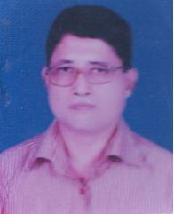 | DR. MD. ABU BAKKOR SIDDIQUE  F/Name: Late Shukuru Mohammed  M/Name: Late Sarah Khatun  BM & DC Reg. No: 9016  NID: 2726412207740  Cell: 01743344405  Address: Director. Dinajpur Meddical College Hospital Dinajpur  Blood Group: B+
142 | Voter No  LM-1500142  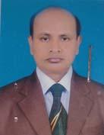 | DR. SHEIKH FARID AHMED  F/Name: Md. Akbar Ali  M/Name: Late Farigannesa  BM & DC Reg. No: 19215  NID: 2726407159496  Cell: 01712567251  Address: Madhya Baluban Infor of Bengal Techno, Dinajpur  Blood Group: O+
143 | Voter No  LM-1500143  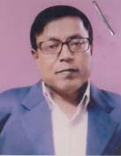 | DR. MOSTOFA ZAHID AHMED  F/Name: Late Kabir Uddin Ahmed  M/Name: Late Gafiron Nessa  BM & DC Reg. No: 14619  NID: 2726408164870  Cell: 01712200804  Address: Law College More, Bahubari, Dinajpur  Blood Group: B+
144 | Voter No  LM-1500144  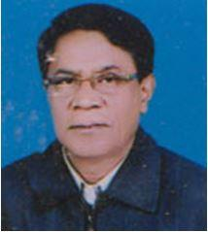 | DR. PARTHA SARATHI RAY  F/Name: Late Charu Chawdra Ray  M/Name: Late Parbati Rani Ray  BM & DC Reg. No: 26146  NID:  Cell: 01726102166  Address: Asst. Prof Surgery Dinajpur Medical College  Blood Group: A+
145 | Voter No  LM-1500145  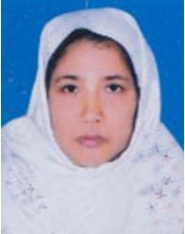 | DR. AYESHA AKHTER BANU  F/Name: Late Dr. Abbas Ali  M/Name: Mrs. Sufia Khatoon  BM & DC Reg. No: 10056  NID: 2726403121277  Cell: 01712565325  Address: Block-8, Plot no- 19, Newtown, Dinajpur  Blood Group: A+
146 | Voter No  LM-1500146  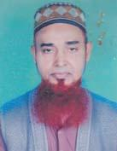 | DR. MD. SHAHAB UDDIN  F/Name: Late Shariat Ulla  M/Name: Mst. Abeda Khatun  BM & DC Reg. No: 15958  NID: 2726409175727  Cell: 01715359573  Address: Plot# 41, Block#6 (Old), New Town Dinajpur  Blood Group: B+
147 | Voter No  LM-1500147  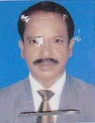 | DR. MD. DIDARUL ISLAM  F/Name: Late Badrul Huda  M/Name: Mst. Rashida Begum  BM & DC Reg. No: 13340  NID: 7727301104833  Cell: 01714383377  Address: Deputy Director, District Family Planing Office, Paharpur, Dinajpur  Blood Group: B+
148 | Voter No  LM-1500148 | DR. NIRMALENDU ROY  F/Name: Late Dayal Chandra Roy  M/Name: Late Chitrani Roy  BM & DC Reg. No: 7297  NID: 2726407164365  Cell: 01715170434  Address: North Balubari (Kumarpara) Sadar, Kotwali, Dinajpur  Blood Group: O+
149 | Voter No  LM-1500149  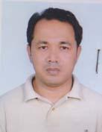 | DR. DIZEN CHANDRA BARMAN  F/Name: Late. Profulla Kumar Barman  M/Name: Josna Barman  BM & DC Reg. No: 30594  NID: 8517663569510  Cell: 01712286183  Address: Balubari, Dinajpur  Blood Group: O+
150 | Voter No  LM-1500150 | DR. SAM HUSNAYEN  F/Name: Md. Belal Uddin  M/Name: Mrs. Asia Khatun  BM & DC Reg. No: 24624  NID: 19682695051000001  Cell: 01714028882  Address: Zia Heart Foundation New Town, Dinajpur  Blood Group: B+
151 | Voter No  LM-1500151 | DR. MANABENDRA ROY  F/Name: Satish Chandra Roy  M/Name: Mira Rani Roy  BM & DC Reg. No: 50432  NID:  Cell: 017477130017  Address: 56/1,Siddeswori Lane,Ramna,Dhaka  Blood Group:
152 | Voter No  LM-1500152 | DR. MD. PARVEZ SOHEL RANA  F/Name: Md. Sirajul Islam  M/Name: Most. Meherun Nessa  BM & DC Reg. No: 44698  NID: 2726402120844  Cell: 01755482445  Address: House No: 295, Road No: 05, Jagoroni Club Road, Patuapara, Dinajpur  Blood Group: O+
153 | Voter No  LM-1500153  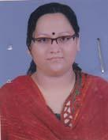 | DR. ZINAT AMAN  F/Name: Md. Zobed Ali  M/Name: Most. Khursheda Banu  BM & DC Reg. No: 45754  NID: 2726402120846  Cell: 01716316836  Address: House No: 295, Road no: 05, Jagoroni Club Road, Patuapara, Dinajpur  Blood Group: B+
154 | Voter No  LM-1500154 | DR. ABU SALEH MD. BADRUL HASAN  F/Name: Late Saifuddin Ahmed  M/Name: Taslima Khatun  BM & DC Reg. No: 17228  NID: 2726409177775  Cell: 01745830750  Address: Asst. Professor, Dept. of Neuro, Dinajpur Medical College, Dinajpur  Blood Group:
155 | Voter No  LM-1500155  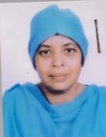 | DR. SHAHANARA BEGUM  F/Name: Late Md. Salehur Rahman  M/Name: Taiyaba Begum  BM & DC Reg. No: 18785  NID: 2726409177716  Cell: 01718843547  Address: Medical Officer (M.O) (MCH-FP) Biral, Dinajpur  Blood Group: B+
156 | Voter No  LM-1500156  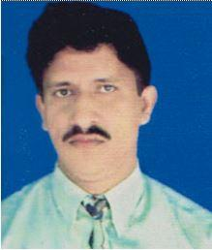 | DR. SYED NADIR HOSSAIN  F/Name: Late Syed Ansarun Nabi  M/Name: Most. Rashida Begaum  BM & DC Reg. No: 22352  NID: 2723802743270  Cell: 01712208176  Address: Room No-95, Medical College Hospital, Dinajpur  Blood Group: O+
157 | Voter No  LM-1500157  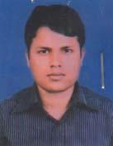 | DR. MD. RAFIQUL ISLAM  F/Name: Md. Abdul Mazid  M/Name: Mrs. Rabeya Begum  BM & DC Reg. No: 52100  NID: 8198510365080  Cell: 01745626211  Address: Quater No: S/P-13, Nimnagar Phulbari Bus-stand, Sadar, Dinajpur  Blood Group: A+
158 | Voter No  LM-1500158 | DR. MD. HASINUR RAHMAN  F/Name: Md. Mokbul Hossain  M/Name: Mrs. Hasina Begum  BM & DC Reg. No: 47229  NID: 2716063308183  Cell: 01712895102  Address: Vill & Post.- Pakerhat, Thana- Khansama, Dinajpur  Blood Group: O+
159 | Voter No  LM-1500159  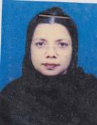 | DR. ASALUN NAYEMA JAN JABILA KHANAM  F/Name: Md. Azizul Islam  M/Name: Tanjila Islam  BM & DC Reg. No: 12790  NID: 8554998195476  Cell: 01819667439  Address: Consultant Paediatric, Arobindo Shishu Hospital  Blood Group:
160 | Voter No  LM-1500160 | DR. A K M SHAHJANUR ALAM  F/Name: Late Tasirubdin Ahmed  M/Name: Late Most Shamshun Nahar  BM & DC Reg. No: 22565  NID:  Cell: 01712972044  Address: Mohajon Para,Sadar, Dinajpur.  Blood Group:
161 | Voter No  LM-1500161  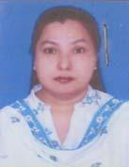 | DR. MST IRINE PARVIN  F/Name: Idris Ali Sarker  M/Name: Rowshan Ara Begum  BM & DC Reg. No: 27557  NID:  Cell: 01716458576  Address: Mohajonpara,Sadar,Dinapur  Blood Group:
162 | Voter No  LM-1500162 | DR. MD. MAHABUBUL ISLAM  F/Name: Late Khademul Islam  M/Name: Ahsan Sabera Kamal  BM & DC Reg. No: 22293  NID: 2726407158059  Cell: 01715412187  Address: Department of Community Medicine, Dinajpur Medical College, Dinajpur-5200  Blood Group: O+
163 | Voter No  LM-1500163  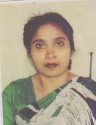 | DR. MST. RAWSHON ARA BEGUM  F/Name: Late Fazlur Rahman Patwari  M/Name: Late Tahera Begum  BM & DC Reg. No: 22585  NID: 2691650166195  Cell: 01718770781  Address: Department of Obst & Gynae Dinajpur Medical College Hospital, Dinajpur-5200  Blood Group: A+
164 | Voter No  LM-1500164 | DR. MD. ABDULLAH-HEL-BAKI (SELIM)  F/Name: Md. Sirajul Islam  M/Name: Mrs. Fareda Islam  BM & DC Reg. No: 41693  NID: 2721205780246  Cell: 01722359332  Address: Vill- Sujapur, Post- Birganj, Upazilla- Birganj, Dist- Dinajpur  Blood Group: B+
165 | Voter No  LM-1500165  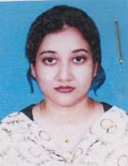 | DR. NASRIN SULTANA  F/Name: Ashraful Alam Prodhan  M/Name: Sultana Razia  BM & DC Reg. No: 45946  NID: 2726405144025  Cell: 01710439731  Address: C/O Ashraful Alam Prodhan (Adrocate); Moholla- Kalitola, Thana-Kotwali, Post+Dist- Dinajpur  Blood Group: O+
166 | Voter No  LM-1500166  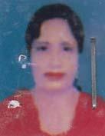 | DR. MRS. TAHERA KHATUN  F/Name: Dr. Sahidullah  M/Name: Most. Firoza Begum  BM & DC Reg. No: 23011  NID:  Cell: 01716129272  Address: Birampur, Ghatpar  Blood Group: B+
167 | Voter No  LM-1500167 | DR. SHAH MOHAMMAD ABDUL MATIN  F/Name: Shah. Md. Abdul Hamid  M/Name: Begum Mukta Hamid  BM & DC Reg. No: 40755  NID:  Cell: 01711200223  Address: Bolck-5, Plot No: 15, Newtown, Dinajpur  Blood Group: O+
168 | Voter No  LM-1500168  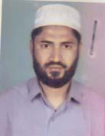 | DR. MD. ZAKIRUL ISLAM  F/Name: Md. Abdul Sattar  M/Name: Mrs. Kohinoor Begum  BM & DC Reg. No: 17760  NID: 2721004868822  Cell: 01712111318  Address: Professorpara, Birampur, Dinajpur  Blood Group: A+
169 | Voter No  LM-1500169  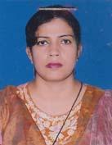 | DR. SHAHNIMA TARAFDER  F/Name: Dr. Md. Shahjahan Tarafder  M/Name: Mst. Shahana Tarafder  BM & DC Reg. No: 28384  NID: 26930116117218  Cell: 01712214310  Address: Block-5, U-13, Newtown, Dinajpur  Blood Group: A+
170 | Voter No  LM-1500170  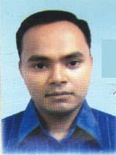 | DR. MD. AHSANUL HAQUE ARSHAD  F/Name: Md. Mobaroke Hossain  M/Name: Mrs. Siddika Khatun  BM & DC Reg. No: 55464  NID: 19852726405000013  Cell: 01711177082  Address: Churipotty, Dinnajpur  Blood Group: O+
171 | Voter No  LM-1500171  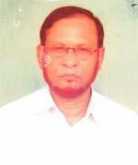 | DR. BORHAN UDDIN AHMED  F/Name: Late Alhaj Bahar Ullah  M/Name: Jobeela Bewa  BM & DC Reg. No: 15911  NID: 2723805753892  Cell: 01711984305  Address: Gouri Para Phulbari, Dinajpur  Blood Group: B+
172 | Voter No  LM-1500172  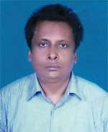 | DR. MD. EMDADUL HOQUE  F/Name: Late Jamal Uddin Ahmed  M/Name: Khairun Nesa  BM & DC Reg. No: 16651  NID: 2726407159915  Cell: 01819661287  Address: Newtown-7, Dinajpur  Blood Group: A+
173 | Voter No  LM-1500173  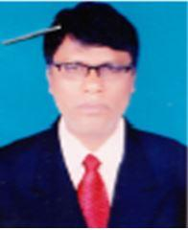 | DR. MOHAMMAD ALI  F/Name: Aftaub Uddin  M/Name: Jamila Khatun  BM & DC Reg. No: 55487  NID: 2726409182883  Cell: 01712135381  Address: New Town-7, Dinajpur  Blood Group: A+
174 | Voter No  LM-1500174  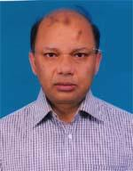 | DR. MD. RUHUL AMIN  F/Name: Late Dr. Aziz Uddin Ahmed  M/Name: Mrs. Rahima Khatun  BM & DC Reg. No: 21614  NID: 2699501947696  Cell: 01715985129  Address: Polu Clinic, Sadar Hospital Road, Munshipara, Dinajpur  Blood Group: O+
175 | Voter No  LM-1500175  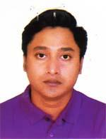 | DR. MD. RAFAAT UL ISLAM KHAN  F/Name: Ifm. Shahidul Islam Khan  M/Name: Anjuman Ara Islam Khan  BM & DC Reg. No: 75684  NID: 2695042763516  Cell: 01712568393  Address: 603, Shams Tower, 2/6 Shahjahan Road, Mohammadpur, Block-C, Dhaka  Blood Group: O+
176 | Voter No  LM-1500176 | DR. MD. SHAHAJAHAN ALI  F/Name: Md. Yeasin Ali  M/Name: Mrs. Sufia Begum  BM & DC Reg. No: 36482  NID: 2727709429131  Cell: 01712876407  Address: Dinajpur Sadar, Dinajpur.  Blood Group: B+
177 | Voter No  LM-1500177  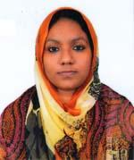 | DR. MALEKA AFRIN  F/Name: Mazibur Rahman  M/Name: Tohsina Begum  BM & DC Reg. No: 49980  NID: 2726409181270  Cell: 01722399903  Address: Churipotty, Dinajpur  Blood Group: B+
178 | Voter No  LM-1500178  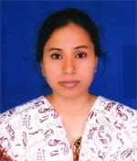 | DR. LIPIKA RANI ADHIKARY  F/Name: Jamini Kanta Adhikary  M/Name: Nioti Rani Adhikary  BM & DC Reg. No: 49174  NID: 8524904042246  Cell: 01738987267  Address: Morshed Bhavan, Mid Balubari, Dinajpur  Blood Group: O+
179 | Voter No  LM-1500179  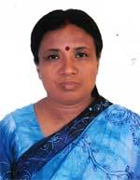 | DR. PURABI ROY  F/Name: Prof. Lalit Mohan Roy  M/Name: Mrs. Madhuri Roy  BM & DC Reg. No: 20108  NID: 2726407160420  Cell: 01715549315  Address: Lec, Physiology Dept. Dinajpur Medical College , Dinajpur  Blood Group: A+
180 | Voter No  LM-1500180 | DR. MOLLA MD. JALAL HOSSAIN  F/Name: Molla Joynal Abedin  M/Name: Shamsun Nahar  BM & DC Reg. No: 33658  NID: 2726402118073  Cell: 01715361641  Address: 246, Kanchan Road, Ghasipara, Dinajpur  Blood Group: B+
181 | Voter No  LM-1500181 | DR. MINARA PARVIN  F/Name: Md. Mansur Ali  M/Name: Mrs. Hosnae Ara Begum  BM & DC Reg. No: 39778  NID:  Cell: 01733526673  Address: North Balu Bari, Gawsia Road, Dinajpur  Blood Group: AB+
182 | Voter No  LM-1500182  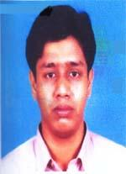 | DR. MD. ASHIQ IQBAL  F/Name: Md. Aminul Haque  M/Name: Mrs. Jahanara Begum  BM & DC Reg. No: 39777  NID: 2726410192728  Cell: 01713084676  Address: North Balu bari, Gausea Road, Sadar, Dinajpur  Blood Group: O+
183 | Voter No  LM-1500183 | DR. MD. BIPLOB BISHWAS  F/Name: Md. Abdur Rahaman Bishwas  M/Name: Most. Sanowar Begum  BM & DC Reg. No: 50543  NID: 8524904043207  Cell: 01773233868  Address: Lecture , Anatomy department. Dinajpur Medical College, Dinajpur  Blood Group: A+
184 | Voter No  LM-1500184  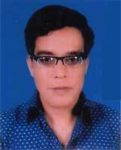 | DR. MUTASIM BILLAH MUHAMMAD IQBAL  F/Name: Late Abbas Ali  M/Name: Begum Meherunnesa  BM & DC Reg. No: 10272  NID: 2726408170195  Cell: 01712029575  Address: Nimnagar, Balubari, Dinajpur  Blood Group: B+
185 | Voter No  LM-1500185 | DR. MD. ASHRAFUL KHALED  F/Name: Allhaj Md. Abdul Khaleque  M/Name: Allhaj Mrs. Ayesha Khatun  BM & DC Reg. No: 39924  NID: 2713015279161  Cell: 01716586017  Address: Gaunul Ajam BNSB. Eye Hospital, Dinajpur  Blood Group: A+
186 | Voter No  LM-1500186  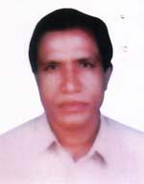 | DR. SUDHARANJAN ROY  F/Name: Late Kaliprosad Roy  M/Name: Mrs. Surobala Roy  BM & DC Reg. No: 12443  NID: 2726407160419  Cell: 01712157897  Address: Superinten Dent, Sia Heart Foundation Hospital & Research Institute Dinajpur.  Blood Group: B+
187 | Voter No  LM-1500187 | DR. SAMIRAN KUNDU  F/Name: Samarendra Nath Kundu  M/Name: Agamoni Kundu  BM & DC Reg. No: 43174  NID: 2726407160590  Cell: 01767461345  Address: mira Kuuja, Introut of Tiluapara Mojid, Uttar Bclubari, Dinajpur, Post Code-5200  Blood Group: B+
188 | Voter No  LM-1500188  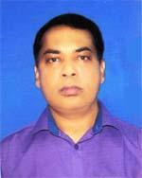 | DR. NOOR MOHAMMAD  F/Name: Late Nurur Huda  M/Name: Mst. Salma Begum  BM & DC Reg. No: 26232  NID: 2650898230371  Cell: 01712541519  Address: Room No.-301, Doctor\'s Dormitory Dinajpur Medical College Hospital, Dinajpur  Blood Group: B+
189 | Voter No  LM-1500189  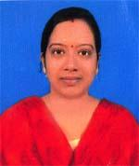 | DR. SUCHITRA NATH  F/Name: Shankar Lal Nath  M/Name: Bina Rani Nath  BM & DC Reg. No: 59725  NID: 6125214204925  Cell: 01723279806  Address: Vill:Uchitpur, Post-Moharajgonj, Thana-Kaharole, Dist-Dinajpur  Blood Group: O+
190 | Voter No  LM-1500190  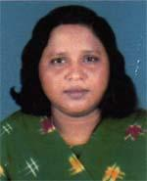 | DR. SHAMIM ARA NAZNEEN  F/Name: Md. Masud Ul Huq  M/Name: Mst. Shahina Begum (nurjahan)  BM & DC Reg. No: 21824  NID: 2726408170157  Cell: 01715249642  Address: Deputy Civil Surgeon, Dinajpur Civil Surgeon Office, Dinajpur.  Blood Group: A+
191 | Voter No  LM-1500191  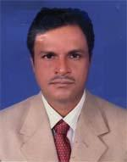 | DR. MD. ASHRAFUL ISLAM  F/Name: Late Md. Rezaul Mondal  M/Name: Most. Sahejan Begum  BM & DC Reg. No: 27048  NID: 2726408170242  Cell: 01716390442  Address: Junior Consultant Eye Parbortipur Upazilla Health Complex, Dinajpur  Blood Group: A+
192 | Voter No  LM-1500192  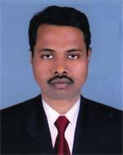 | DR. HILARIUS HEMBROM  F/Name: Manuel Hembrom  M/Name: Rita Hasda  BM & DC Reg. No: 42222  NID: 2726404137092  Cell: 01712853044  Address: Uttar Gosaipur (ChristianPara), Sadar, Dist-Dinajpur  Blood Group: AB+
193 | Voter No  LM-1500193  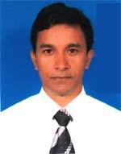 | DR. SIBRATA ROY  F/Name: Dr. Kailash Chandra Roy  M/Name: Hira Rani Roy  BM & DC Reg. No: 29112  NID: 2726406155376  Cell: 01712678551  Address: Registar , Surgery Dinajpur Medical College Hospital, Dinajpur.  Blood Group: O+
194 | Voter No  LM-1500194 | DR. PALLAB KUMAR DAS  F/Name: Naba Kumar Das  M/Name: Maya Rani Das  BM & DC Reg. No: 60816  NID: 19864820606000008  Cell: 01718506235  Address: Dinajpur Diabetis & Swasthoseba Hospital, Dinajpur  Blood Group: A+
195 | Voter No  LM-1500195  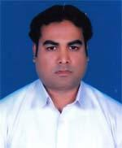 | DR. SUSHANTA KUMAR SEN  F/Name: Nalini Kumar Sen  M/Name: Sumira Sen  BM & DC Reg. No: 42123  NID: 2726405140845  Cell: 01716683317  Address: Dinajpur Medical College Hospital R/A Dinajpur.  Blood Group: A+
196 | Voter No  LM-1500196  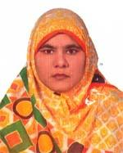 | DR. SONIA PARVIN ISLAM  F/Name: Aminul Islam  M/Name: Momtaz Begum  BM & DC Reg. No: 35808  NID: 2726409184729  Cell: 01716809906  Address: 69, Block-10, New Town, Dinajpur  Blood Group: O+
197 | Voter No  LM-1500197  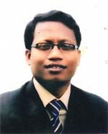 | DR. ASHUTOSH DEB SHARM A  F/Name: Protap Chandra Deb Sharma  M/Name: Komola Debi  BM & DC Reg. No: 39561  NID: 2711776076978  Cell: 01716013647  Address: Nimtola, Sadar, Dinajpur  Blood Group: B+
198 | Voter No  LM-1500198 | DR. MILON KUMAR ROY  F/Name: Porsu Ram Roy  M/Name: Moni Mala Roy  BM & DC Reg. No: 35023  NID:  Cell: 01711068492  Address: Vill-Mirjapur, Post-Rajbati, Sadar, Dinajpur  Blood Group: O+
199 | Voter No  LM-1500199  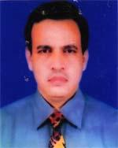 | DR. MOHD. AMINUL ISLAM  F/Name: Moha. Hossain Ali Shah  M/Name: Mrs. Amena Begum  BM & DC Reg. No: 21676  NID: 19672699040723014  Cell: 01711163230  Address: NINIO Department of Orthopaedic Surgery, Dinajpur Medical College Hospital, Dinajpur  Blood Group: A+
200 | Voter No  LM-1500200  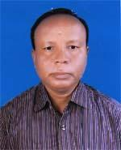 | DR. MANINDRA NATH ROY  F/Name: Late Sitanth Roy  M/Name: Kshir Moui Roy  BM & DC Reg. No: 14606  NID: 19602721201775177  Cell: 01716583744  Address: Dinajpur Medical College Hospital  Blood Group: O+
201 | Voter No  LM-1500201  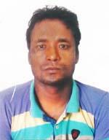 | DR. SANJOY KUMAR ROY  F/Name: Sattyendra Nath Roy  M/Name: Goury Roy  BM & DC Reg. No: 57427  NID: 85249040042988  Cell: 01711220039  Address: Dinajpur Medical College Hospital Dinajpur  Blood Group: A+
202 | Voter No  LM-1500202  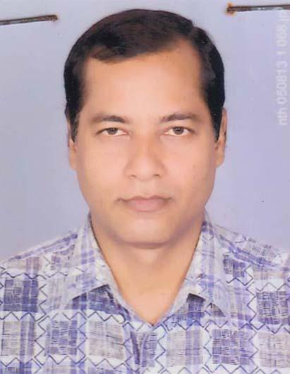 | DR. AMALENDU BISWAS  F/Name: Late Debendra Nath Biswas  M/Name: Late Soneka Rani Biswas  BM & DC Reg. No: 15416  NID: 0921803163982  Cell: 01716040229  Address: Civil Surgeon, Civil Surgeon Office Dinajpur.  Blood Group: B+
203 | Voter No  LM-1500203  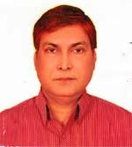 | DR. MD. GOLAM RABBANI  F/Name: Giash Uddin Mondol  M/Name: Begum Shahida Khatun  BM & DC Reg. No: 19316  NID: 2721005871619  Cell: 01712213396  Address: Thana Para Birampur, Word 05, Birampur, Dinajpur  Blood Group: AB+
204 | Voter No  LM-1500204 | DR. PHALGUNI CHAKRABORTTY  F/Name: Ashoke Kumar Chakrabortty  M/Name: Sima Chakrabortty  BM & DC Reg. No: 46187  NID: 2726407159588  Cell: 01717486951  Address: Mira Kunja, Indront of Tikiapara Mosjid Uttar Balubari, Dinajpur, Post Code-5200  Blood Group: O+
205 | Voter No  LM-1500205 | DR. NIBEDITA PAUL  F/Name: Dr. Biswa Nath Paul  M/Name: Arati Paul  BM & DC Reg. No: 46377  NID: 2726406155338  Cell: 01857372744  Address: Lecturer, Biochemistry, Dinajpur Medical College  Blood Group: AB+
206 | Voter No  LM-1500206  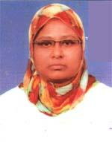 | DR. MOST. RAHANA PARVIN RINA  F/Name: Md. Abdur Razzaque  M/Name: Mst. Lailatun Nehar  BM & DC Reg. No: 60887  NID: 2711785083926  Cell: 01764878607  Address: Village-Jogotpur, P.O-Bozrapur , Dinajpur.  Blood Group: B-
207 | Voter No  LM-1500207 | DR. MIRJA SORIFUL ISLAM  F/Name: Mirza Mozammel Haque  M/Name: Mst. Rahima Khatun  BM & DC Reg. No: 62107  NID: 19882716469409522  Cell: 01719261547  Address: USC, Sadar, Dinajpur  Blood Group: B+
208 | Voter No  LM-1500208  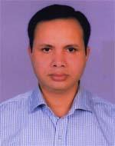 | DR. MD. AYNUL ISLAM  F/Name: Md. Jaynal Abedin  M/Name: Most. Ambia Khatun  BM & DC Reg. No: 36265  NID: 7311585874636  Cell: 01739907528  Address: 69, Block-10, New Town, Dinajpur  Blood Group: AB+
209 | Voter No  LM-1500209  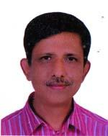 | DR. S. M. WARES ALI SARKER  F/Name: Md. Anwar Sarker  M/Name: Anwara Sarker  BM & DC Reg. No: 14961  NID: 21164943119982  Cell: 01712527508  Address: Munshipara, Dinajpur  Blood Group: B+
210 | Voter No  LM-1500210  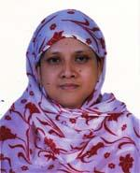 | DR. ZEENAT REHANA  F/Name: Alhaj Zaforuddin Ahmed  M/Name: Momotaj Begum  BM & DC Reg. No: 43138  NID: 2716494349979  Cell: 01818230982  Address: Munipara, Dinajpur  Blood Group: B+
211 | Voter No  LM-1500211 | DR. SHAH MD. ISMAIL HOSSAIN  F/Name: Shah Ibrahim  M/Name: Mrs. Asma Khatun  BM & DC Reg. No: 34042  NID:  Cell: 01714034995  Address: Dinajpur Medical College Hospital Dinajpur.  Blood Group: AB+
212 | Voter No  LM-1500212  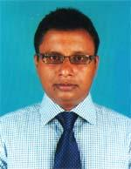 | DR. MD. MONJUREELAHI  F/Name: Md. Nazrul Islam  M/Name: Mrs. Sayeda Islam  BM & DC Reg. No: 40972  NID: 2721201775211  Cell: 01740877779  Address: Room No.-411, Dinajpur Medical College Hospital, Dinajpur  Blood Group: B+
213 | Voter No  LM-1500213  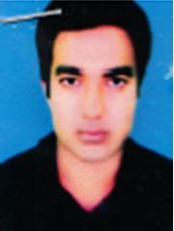 | DR. MD. MOKTARUZZAMAN  F/Name: Md. Ashraf Ali  M/Name: Mrs. Monowara Begum  BM & DC Reg. No: 43891  NID: 19811516127268480  Cell: 01716911470  Address: dinajpur Sadar, Dinajpur.  Blood Group: B+
214 | Voter No  LM-1500214  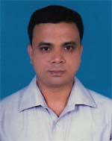 | DR. MD. SARAWARUL ISLAM MUKTA  F/Name: Md. Ohidul Haque  M/Name: Most. Ramicha Khatun  BM & DC Reg. No: 32397  NID: 2723802745267  Cell: 01711976839  Address: Munshipara, Sadar, Dinajpur  Blood Group: A+
215 | Voter No  LM-1500215 | DR. SUSHAIN CHANDRO RAY  F/Name: Giridhar Bormon  M/Name: Vupati Roy  BM & DC Reg. No: 36743  NID: 7318554107667  Cell: 01711972407  Address: Sahid Minar Mor, Balubari, Kotwali, Dinajpur  Blood Group: B+
216 | Voter No  LM-1500216 | DR. MD. AMIR UDDIN  F/Name: Late Ismail Hossain  M/Name: Late Dhela Khatun  BM & DC Reg. No: 12958  NID: 2716416390049  Cell: 01717977385  Address: Assistant Prof. Fi Mediciul DFMC Dinahpur.  Blood Group: B+
217 | Voter No  LM-1500217  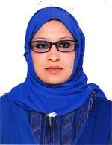 | DR. NOORAY FATEMA JANNATUN NOORI  F/Name: Md. Yeakub Ali  M/Name: Most. Momotaj Begum  BM & DC Reg. No: 46967  NID: 19832698882810143  Cell: 01716380120  Address: Vill-Uchitpur, Post-Moharajgonj, Upazilla-Kaharol, Dist-Dinajpur  Blood Group: AB+
218 | Voter No  LM-1500218 | DR. SHILADITYA SHIL  F/Name: Kshitish Chandra Shil  M/Name: Protima Shil  BM & DC Reg. No: 35599  NID: 19782619551165367  Cell: 01715131611  Address: Borobandar, Natun Para, Sadar, Dinajpur  Blood Group: AB+
219 | Voter No  LM-1500219  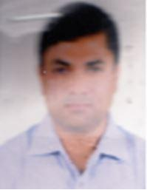 | DR. MD. HARISUR RAHMAN  F/Name: Late Dr. Tamizuddin Ahmed  M/Name: Hosne Ara Begum  BM & DC Reg. No: 24747  NID: 2691651185046  Cell: 01818795474  Address: Dhasuoara, Dinajpur-5200  Blood Group: O+
220 | Voter No  LM-1500220 | DR. SHUVA MUKHERJEE  F/Name: Late Monindra Nath Munhesjee  M/Name: Basanti Rani Chakrobortty  BM & DC Reg. No: 48307  NID: 2726407164631  Cell: 01719131054  Address: Manindra Sadan, House No.-1219, Road 5/C, North Balvbari, Post+Dist-Dinajpur  Blood Group: B+
221 | Voter No  LM-1500221  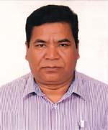 | DR. SARAL CHANDRA ROY  F/Name: Late Mahi Nath Roy  M/Name: Late Sukheshwary Roy  BM & DC Reg. No: 14435  NID: 2726405145576  Cell: 01715015020  Address: UHC, Bochaganj, Dinajpur  Blood Group: O+
222 | Voter No  LM-1500222  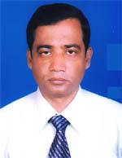 | DR. MD. NURUL ISLAM  F/Name: Md. Moktal Hossain  M/Name: Mrs. Nurjahan Begum  BM & DC Reg. No: 21004  NID: 2716015301791  Cell: 01718617128  Address: Residence of Hospital Medical College Campus, Dinajpur  Blood Group: A+
223 | Voter No  LM-1500223  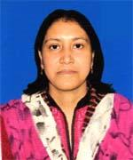 | DR. ZOBAYDA GULSAN ARA  F/Name: Md. Zoynal Abadin  M/Name: Monju Ara Abadin  BM & DC Reg. No: 39720  NID: 2726411201997  Cell: 01712556396  Address: Eidgah Residential Area, House # 243, Road # 6, Block-A, Dinajpur  Blood Group: B+
224 | Voter No  LM-1500224 | DR. MOHAMMAD ABUJER RAHMAN  F/Name: Mohammad Solaiman Sarker  M/Name: Mrs. Golejam Begum  BM & DC Reg. No: 35451  NID: 2993014956547  Cell: 01711730765  Address: Dinajpur Medical College More , Dinajpur  Blood Group: A+
225 | Voter No  LM-1500225  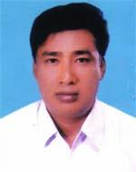 | DR. NIRMAL KUMAR BARMAN  F/Name: Annada Charan Barman  M/Name: Luxmi Rani Roy  BM & DC Reg. No: 24632  NID: 8515867775517  Cell: 01915667414  Address: Sahidminar Mor. Balubari, Kotwali, Dinajpur  Blood Group: B+
226 | Voter No  LM-1500226  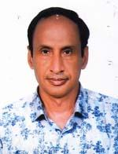 | DR. MOHAMMAD REZA HABIB  F/Name: Mohammad Habibur Rahman  M/Name: Rabeya Khatun  BM & DC Reg. No: 26321  NID: 2726402118812  Cell: 01716263334  Address: 165, Chawliapatty, Dinajpur  Blood Group: A+
227 | Voter No  LM-1500227 | DR. MD. NURUL ISLAM  F/Name: Md. Abdul Aziz  M/Name: Mrs. Hafiza Begum  BM & DC Reg. No: 24500  NID: 6125214207842  Cell: 01795074922  Address: H=120, W=10, Paharpur, Dinajpur  Blood Group: O+
228 | Voter No  LM-1500228  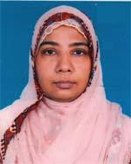 | DR. ISHRAT SHARMIN  F/Name: Md. Yeahia  M/Name: Late Marufa Begum  BM & DC Reg. No: 26456  NID: 2691651185047  Cell: 01819122727  Address: Ghashipara, Sadar, Dinajpur  Blood Group: AB+
229 | Voter No  LM-1500229  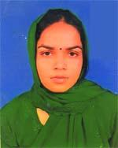 | DR. MOSTARINA BEGUM  F/Name: Golam Mostofa  M/Name: Rowshon Ara Begum  BM & DC Reg. No: 57401  NID: 8198510364433  Cell: 01671907312  Address: New Town 7 No. House No. I/8, Sadar, Dinajpur  Blood Group: AB+
230 | Voter No  LM-1500230 | DR. BIPUL CHANDRA ROY  F/Name: Late Subodh Chandra Roy  M/Name: Sudha Roy  BM & DC Reg. No: 42407  NID: 2716425231089  Cell: 00  Address: Basumia polli, Sadar Dinajpur  Blood Group: O+
231 | Voter No  LM-1500231  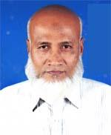 | DR. MD. YOUNUS ALI  F/Name: Md. Saidur Rahman  M/Name: Mrs. Abeja Khatun  BM & DC Reg. No: 9939  NID: 2027703415646  Cell: 01741290290  Address: Rustomneal, Parbotipur, Dinajpur  Blood Group: B+
232 | Voter No  LM-1500232  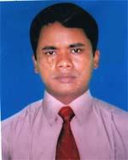 | DR. NIKHILEHWAR ROY  F/Name: Jogeshwar Chandra Roy  M/Name: Maya Rani Roy  BM & DC Reg. No: 37458  NID: 2726406155333  Cell: 01732642271  Address: Kumarpara, Balubari, Dinajpur  Blood Group: O+
233 | Voter No  LM-1500233  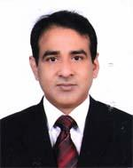 | DR. MD. TAHIDUR RAHMAN  F/Name: Md. Khademul Islam  M/Name: Mrs. Nurzahan Begum  BM & DC Reg. No: 39135  NID: 9419426206738  Cell: 01712589885  Address: Neemtola, Sadar, Dinajpur  Blood Group: A+
234 | Voter No  LM-1500234  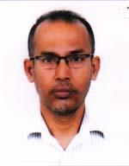 | DR. TIMIR BARAN BASAK  F/Name: Prozyul Basak  M/Name: Urmilla Basak  BM & DC Reg. No: 15290  NID: 7625505137030  Cell: 01715367124  Address: Dinajpur Medical College Dinajpur.  Blood Group: O+
235 | Voter No  LM-1500235  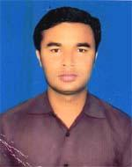 | DR. UDAY KUMAR SARKER  F/Name: Debendra Nath Sarker  M/Name: Giribala Rani  BM & DC Reg. No: 65039  NID: 19902717777000476  Cell: 01719401129  Address: Vill-Uttar Dhobakal Balapara, Post-Busms, P.s-parbatipur, Dist-Dinajpur  Blood Group: O+
236 | Voter No  LM-1500236 | DR. MD. SHAMIUL HOSSAIN  F/Name: Md. Zakaria  M/Name: Mrs. Jamila Begum  BM & DC Reg. No: 38327  NID: 9428607773298  Cell: 01718200690  Address: Asst. Professor (Gastroenturology), Dinajpur Medical College, Dinajpur  Blood Group: A+
237 | Voter No  LM-1500237  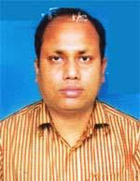 | DR. TAPASH KUMAR DATTA  F/Name: Tarani Kanta Datta  M/Name: Dipali Rani Datta  BM & DC Reg. No: 34201  NID: 2723808761207  Cell: 01716147335  Address: Vill-Katabari, Post+Thana-Phulbari, Dist-Dinajpur  Blood Group: A+
238 | Voter No  LM-1500238  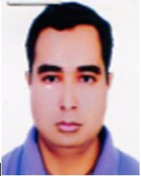 | DR. MD. ALAMGIR HOSSAIN  F/Name: Md. Abul Hossain  M/Name: Lutfa Begum  BM & DC Reg. No: 54150  NID:  Cell: 01772800100  Address: Munshipara, Sadar, Dinajpur  Blood Group: O+
239 | Voter No  LM-1500239 | DR. SAKI MD. JAKIUL ALAM  F/Name: Md. Rafiqul Islam  M/Name: Mrs. Mobassera Begum  BM & DC Reg. No: 24846  NID: 2694263709632  Cell: 01711600892  Address: Associate Prof. Dept. of Medicine, Dinajpur Medical College Dinajpur.  Blood Group: B+
240 | Voter No  LM-1500240  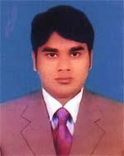 | DR. SANJAY KUMAR GUPTA  F/Name: Late Shital Prosad Gupta  M/Name: Basona Devi  BM & DC Reg. No: 50563  NID: 6125211185499  Cell: 01741404844  Address: Vill-Kantabari, Post+P.s-Fubari, Dist-Dinajpur  Blood Group: O-
241 | Voter No  LM-1500241  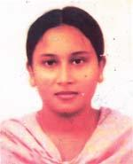 | DR. SINTHIA SIDDIQUA  F/Name: Late Abu Bakar Siddique  M/Name: Nurun Nahar Begum  BM & DC Reg. No: 51017  NID: 8520307339867  Cell: 01712933829  Address: Rangpur Medical College Hospital, Gynee and Obst Dept. Rangpur  Blood Group: B+
242 | Voter No  LM-1500242  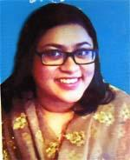 | DR. MEGHNA TAHSIN REZA  F/Name: Faridur Reza Sagor  M/Name: Kona Reza  BM & DC Reg. No: 64257  NID: 2696653243864  Cell: 01717094101  Address: 2/6, Shahjahan Road, 603, Mohammadpur, Dhaka  Blood Group: O-
243 | Voter No  LM-1500243 | DR. MD. RAZIUL ISLAM  F/Name: Md. Monsur Ali  M/Name: Rasheda Begum  BM & DC Reg. No: 61014  NID: 2726407164281  Cell: 01797739868  Address: North Balubari, Kumarpara, Sadar, Dinajpur  Blood Group: A+
244 | Voter No  LM-1500244  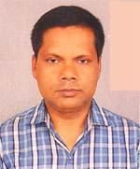 | DR. MD. ASIDUZZAMAN  F/Name: Md. Sazzad Ali  M/Name: Most. Shamsun Nahar Begum  BM & DC Reg. No: 31992  NID: 2726406149679  Cell: 01718287748  Address: Nahar Villa, Fokirpara, Post-Churipotti, Thana-Sadar, Dist-Dinajpur  Blood Group: A+
245 | Voter No  LM-1500245  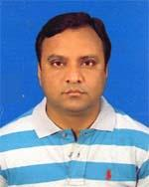 | DR. MD. NURUZZAMAN  F/Name: Md. Abdul Hafiz  M/Name: Mrs. Nurnnaher Begum  BM & DC Reg. No: 36908  NID: 8524904042149  Cell: 01718088901  Address: Room-413, Dinajpur Medical College Dinajpur.  Blood Group: B+
246 | Voter No  LM-1500246  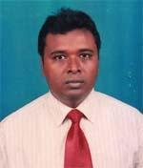 | DR. MD. AROZ ULLAH  F/Name: Md. Reazul Haque  M/Name: Mst. Asiha Khatun  BM & DC Reg. No: 21047  NID: 2726408170156  Cell: 01716604405  Address: UH&FPO, Upazilla Health Complex , Kaharol, Dinajpur  Blood Group: A+
247 | Voter No  LM-1500247 | DR. NIKOLAS CHANDRA ROY  F/Name: Upendro Nath Roy  M/Name: Jyotsna Roy  BM & DC Reg. No: 40820  NID: 2712140838376  Cell: 01715622015  Address: Morshed Bhaban, Mid Balubari, Dinajpur  Blood Group: A+
248 | Voter No  LM-1500248  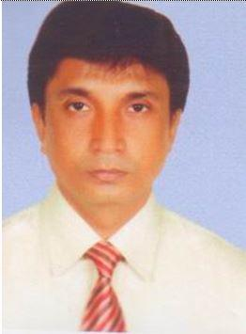 | DR. MD. ABDUS SALAM  F/Name: Giasuddin Ahmed  M/Name:  BM & DC Reg. No: 23469  NID:  Cell:  Address: Asstt. Professor Dept.. Of Surgery Dinajpur Medical College, Dinajpur.  Blood Group:
249 | Voter No  LM-3300005  No Image | DR. MD. ABDUL HAMID SARKER  F/Name:  M/Name:  BM & DC Reg. No:  NID:  Cell:  Address: Medical Officer, (Clinic)  Lalmonirhat.  Blood Group:

